SUNUM HEALTH&SAFETY PROTOCOLS USER VERIFICATION TEST

Name:

e-mail/phone:

Date:

1. To summon help in an emergency within the Campus, which phone number should you dial FIRST?
2. 9988
3. 2440
4. 6666
5. 5555
6. The best time to plan procedures for cleaning up a chemical spill is:

a) Immediately after the spill occurs

b) Just before the Hazardous Material Team arrives

c) Before beginning to use the chemicals

1. It is not safe to store acetone with which of the following:
2. Methanol
3. Nitric Acid
4. Ammonium hydroxide
5. When should you call Campus Safety or Security? List 5 conditions
6. What is the SUNUM Facilities Emergency Phone Number?
7. If a loud bell sounds, what could this mean and what should you do?
8. In the event of major gas leak, what should you do?
9. During the earthquake, what should you do?
10. Run outside quickly
11. Use elevator, use stairs to get out quickly
12. Drop, Cover, Hold on
13. What does a MSDS stand for? What is it used for?
14. You can drink tea, coffee within the lab premises?
15. True
16. False
17. What are the key points you should be planning before starting an experiment? Name 5.
18. What does this image stand for?

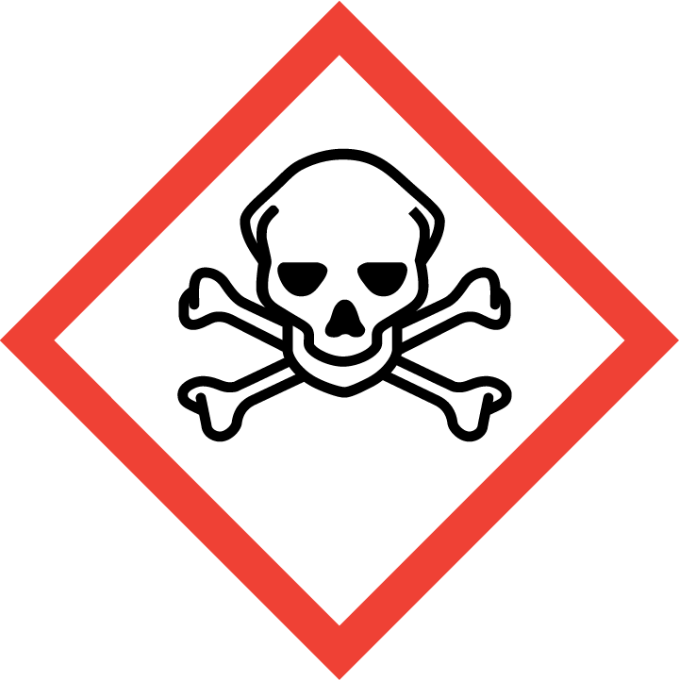

a) Carcinogenic agent

b) Corrosive material

c) Toxic material

13. Solvent and chemical waste can be poured in drains

1. True
2. False

14. Signing IN the equipment log-book AFTER the equipment use

1. True
2. False